**IAM:**

Create compartments

Network

App

DB

Shared compartment

Create user with name “usercom” with complete access on compartment App

Create network user with complete access on compartment network

Create user2 with read only access on tenancy.

provide user “usercom” use access to network compartment

**Network:**

Create one VCN with cidr 10.0.0.0/16 and create two subnets one is public(10.0.0.0/24) and other is private(10.0.1.0/24)

And find out how many hosts reside in each subnet

Use only NSGs instead of SL

**Compute:**

Create one instance in public subnet and try to connect from putty through public ip

Create one instance in private subnet and try to connect from putty through jump host with one ocpu and 8gb (above vm) and this vm should be able to connect to internet (add the required gateway)

Increase the ocpus from one to two later.

Create two VCNS with non overlapping CIDRs and try to establish connectivity using LPG and DRG

**Storage:**

**Blockstorage:**

Add 50GB storage to one instance with mount point name /oracle using IScsi in windows and linux

Extend the 50 GB storage to 200 GB on both linux and windows

Add 50GB storage to one instance mount point name /oracle using paravirtualised in windows and linux

Extend the 50 GB storage to 200 GB on both linux and windows

**Filestorage:**

Create fss with name sharedfilesystem and mount it with mount pointname /data on two instances.one instance should have read and write permissions and other instance should have only read permission

**Object storage:**

Create bucket1 with standard Tier and add objects in it.

Create pre-authenticated request for 2 days and share the link. From that link try to download the file without logging into the server.

Upload 3 different objects with different standard , infrequent access, archival storage tiers and observe which options were disabled and enabled for each tier

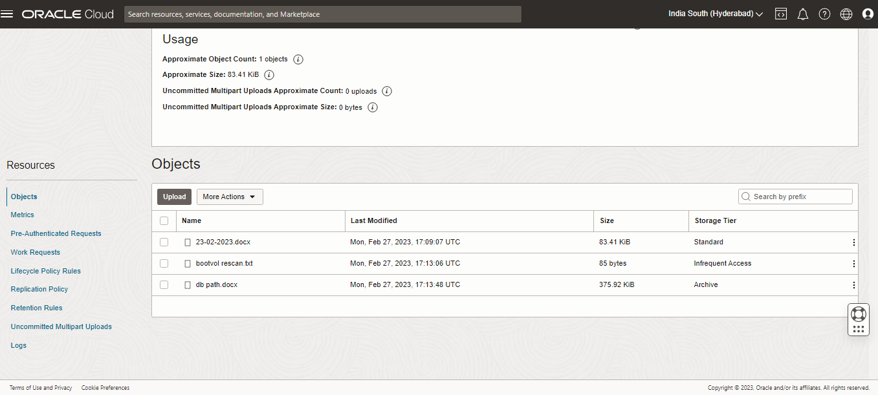

1.)Understand the life cycle rule and set the number of days to “10” and after 10 days object should be deleted .

2.)Learn about Object Replication policy.

3.)Apply retention rule and try to delete the objects and note the difference.

4.)check what happens when retention rule is locked.

5.)Enable auto-tiering feature and make a note of what it does.

Create bucket2 with Archival Tier and add objects in it.